\



THE DUNCAN LOUIS STEWART FELLOW: NATURAL HISTORY

  - CANDIDATE INFORMATION PACK
02
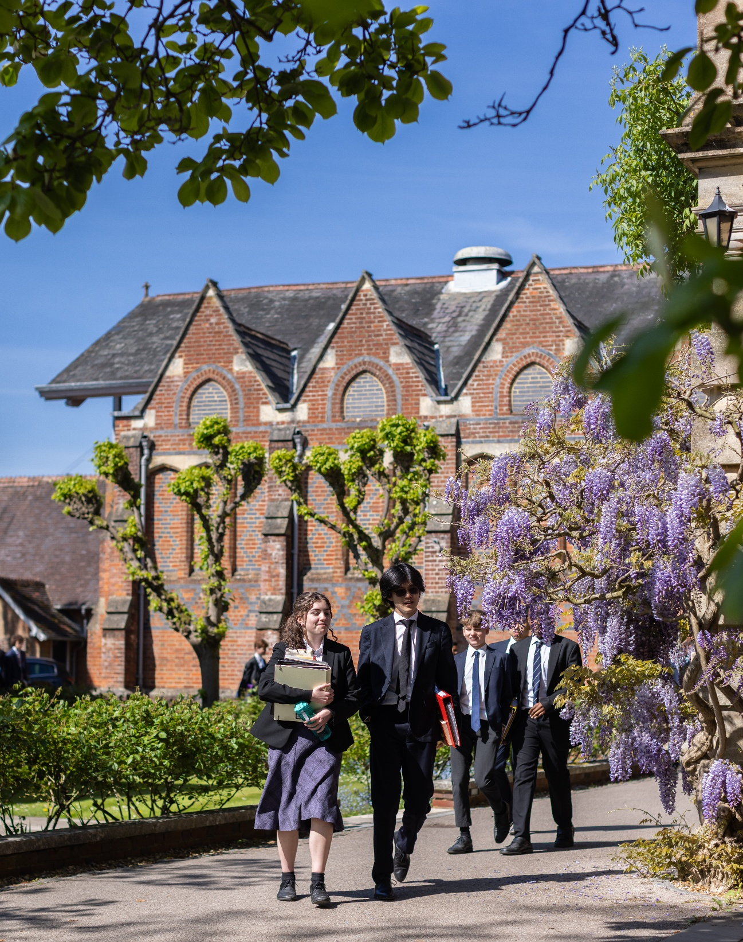
CLOSING DATE FOR APPLICATIONS 27 May 2026

Early applications are encouraged, and the school reserves the right to close
the application process early should a suitable candidate be found.

PART ONE
03

ABOUT THE ROLE

Founded in 1870, the Natural History Society (NHS) is among the very oldest of Winchester College’s societies. The arrival of Duncan Stewart, in 2003, saw the NHS acquire a new lease of life, after somewhat lean times, and become the best-supported society in the school. A full programme of termly trips was instigated, the library was restocked and equipment updated. Duncan’s enthusiasm and determination set a template for others to follow.

Duncan Stewart (G, 2003-08) was just eighteen when he was tragically killed as a passenger in a car accident. He had been working as a marine biologist during his gap year in Argyll. Growing up in Scotland, Duncan had a passion for the outdoors and particularly enjoyed scuba diving, tennis, snorkelling, birdwatching, and climbing. He was able to pursue his love of fishing at Winchester with many summer days and evenings spent on the River Itchen. Duncan kept meticulous journals and notebooks of his observations in nature and worked on organising the Winchester College Natural History collections, helping to organise, index, collate and make extensive drawings of the specimens. Duncan invited Sir David Attenborough to speak to the NHS. As a result of this, Sir David subsequently became the society's Honorary President and remains an Honorary Patron to this day. Duncan wrote in his invitation letter to Sir David:

‘The Winchester College NHS aims to educate the boys about the extraordinary biodiversity of Hampshire, southern England and the world.’

David and Kim Stewart have worked extensively with the school to build a legacy for Duncan's passion for the natural world. In 2009, the College established the annual Duncan Louis Stewart Natural History Lecture. In 2015, the Stewart family and other generous donors endowed Winchester with a fund to support the Duncan Louis Stewart Fellowship in Natural History in his memory. The aim of the fellowship is to make the natural world relevant to all pupils, in all areas of study. It encourages Wykehamists to observe, study, comprehend and care about the natural world around them, to attract and encourage polymathic thinking and discussion about our shared natural world. The Fellow will work alongside all departments.

Key aim of the Duncan Louis Stewart Fellowship in Natural History:

To engender the largest possible number of pupils a deeper knowledge, love and respect for, ecology, the environment and the natural world around them.

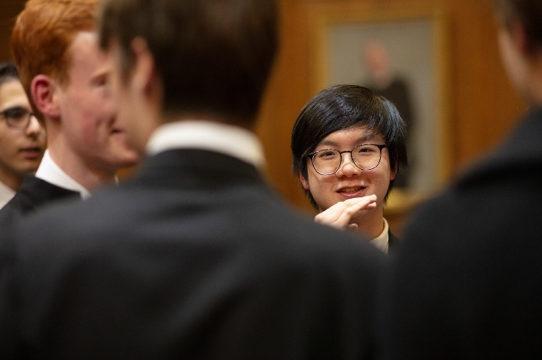

PART TWO

ROLE AND RESPONSIBILITIES

The key role and responsibility of the Fellow will be to inspire and facilitate the pupils, and the school, as we grow and increase our contribution to, and general awareness of the natural world around us. Winchester College aims to contribute to caring for and protecting our natural world and planet well beyond our own boundaries.
Responsible to: The Head of Science, Matt Rogers.

They will achieve the above key aim through:
- Planning and organising a range of activities on a weekly basis including:
- NHS weekly activities and trips alongside the Master in Charge of the NHS and a Thursday drop-in session for project work and animal husbandry (e.g. tank maintenance; reptile, amphibian and insect feeding)
- Community Service conservation focused weekly activities in conjunction with the Director of Community Service.
- Leading a weekly natural history activity for pupils focused on project work in the immediate surroundings of the College. This will involve publicising and keeping accurate records of findings. Activities may include but not be limited to:
- Rigorous survey work of flora and fauna (e.g. water vole, otters and aquatic invertebrates).
- Camera trap and remote observation-based monitoring, with links to the school’s website and other wildlife websites.
- Outreach activities with local schools in support of the Head of Educational Partnerships (potentially including a week of work experience for GCSE pupils, as well as ad-hoc ecology fieldwork sessions).
- Working with the Head of Scientific Collections to identify, catalogue and display natural history collections.
- Planning and coordinating the annual Duncan Louis Stewart NHS lecture from a high-profile naturalist in collaboration with the Winchester College Society.
- Working with the Admissions team on Our Futures Together programme for prospective students to experience Ecology related activities.

- Building and maintaining links via the activities listed above with local wildlife organisations and the wider community.
- Attending a number of field trips, both residential and non-residential, either as a natural history expert who can significantly boost pupil engagement, or as the principal organiser of inspiring nature focused trips. These will include:
  - Nature-based trips such as:
- Planning and organising an annual residential trip for the NHS (7 days).
- Fortnightly local trips off-site for the NHS (e.g. Marwell Zoo, New Forest)

  - Attending fieldwork associated with the teaching of Geography, such as:
- Non-residential days during term-time.
- 3 days residential during term-time.
- 7 days residential outside of term-time.

  - Attending fieldwork associated with the teaching of Biology, such as:

- Non-residential days during term-time.

  - Engaging with teaching staff in order to:
- Work with all academic departments and those who teach Div on any natural history related projects (e.g. EPQs) and classes.
- Work with Earth Prize teams to support the success of their projects.
- Visit tutor groups and getting pupils to engage in ecological activities during a 35 minute lesson.
- Identify opportunities to engender in all pupils a deeper knowledge of, and respect for ecology, the environment and the natural world.
- Promote and advertise natural history by contributing to the program of short talks in boarding houses in the evening and chapel in the morning.

- The successful candidate will work in Winchester throughout the week in term-time. There will be a need to support activities at weekends during term-time and field trips will infringe on weekends and school holidays.

These
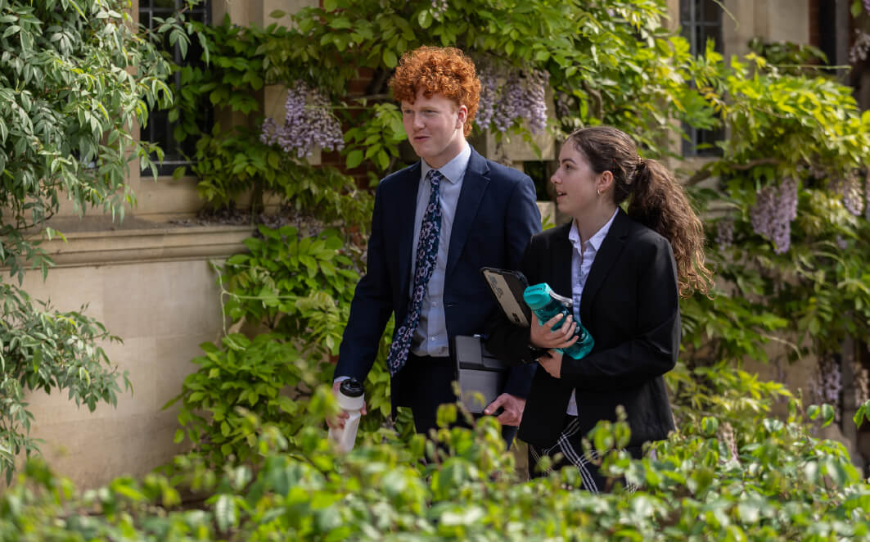

PART THREE

PERSON SPECIFICATION AND KEY QUALITIES

Essential

The successful candidate will be/have:

- A passion for natural history evidenced through either higher academic study, research and publications, the media or through professional pursuits.
- Extensive knowledge and experience of wildlife and practical study of natural history.
- The ability to enthuse and stimulate interest in young people and convey this knowledge effectively.
- Be on hand to fulfil the job requirements, both locally and further afield.
- Be a proactive person able to work alone and generate ideas and put them into practice effectively.
- Be a good communicator able to converse with a wide range of people.
- It is also expected that the Duncan Louis Stewart Fellow in Natural History will have a relevant honours degree or equivalent and have current contacts with wildlife organisations.

Key Qualities

The successful candidate will be/have:

- A commitment to the pastoral values of the school.
- Enjoyment of young people’s company.
- Emotional intelligence and the ability to empathise with both staff and pupils.
- A welcoming and friendly demeanour for all visitors to the College.
- The ability to build strong and effective relationships with pupils, parents, other Housemaster/mistress and other school-wide colleagues.
- Calm, patient and the ability to make decisions under pressure.
- The ability to delegate and use initiative.
- High levels of energy, enthusiasm and reliability.
- Excellent behaviour management skills.
- Organisational and administrative skills.
- The resilience and stamina needed to deal with the demands of boarding school life.
- Commitment to promoting and embedding an inclusive culture, with equality of opportunity for all.

PART FOUR

BENEFITS, TERMS AND CONDITIONS AND APPLICATION

Start Date
The College is looking to make an appointment to start in September 2026. Exact start date is negotiable.

Salary
The salary will be in circa £33,000 per annum. Salary levels are reviewed annually on 1 September, and this salary will next be reviewed in September 2027.

Hours of Work
This is a full-time role during term time, 32 weeks of the year, with an element of work during the holiday period not exceeding 4 weeks per academic programme. Normal working hours will be 37.5 hours per week spread over mostly Monday to Friday with occasional Saturdays (e.g. Wykeham Day and fieldtrips). This will usually include one later evening (staying until approximately 10pm) each week. The school is open for approximately 26 Saturdays during the year.

Induction and Continuous Training and Development
The school is fully committed to the induction, training and development of all our staff, with staff supported to grow and reach their full potential.
We deliver a range of training, run by both our own staff and external providers, varying from highly practical First Aid courses to seminars and learning lunches on many aspects of teaching and learning.
There is an annual cycle of appraisal offering the opportunity to reflect on professional practice and development opportunities.

Probation and Notice Periods
The first four months of employment will be a probationary period. During this time, conduct and performance will be reviewed. The College may extend the probationary period if it is deemed to be required. During the probationary period the notice required to terminate employment will be one week (by either the employee or employer). The notice will increase upon the successful completion of the probationary period to one term.

Private Pension
On employment, employees will be auto enrolled into the College’s pension scheme according to legislative thresholds. Those who are not eligible for auto-enrolment may still elect to join the College’s pension scheme.
Initially, when joining the College’s pension scheme, employees will become a member of the College’s Group Personal Pension Plan (GPP). For this Plan, known as Tier 1, the employee contributes 4% and the employer 3%.
After 9 month’s membership of the Tier 1 plan, employees may opt to join Tier 2, which is also a GPP, where the employee contributes 5% and the employer 9%.
Employees in Tier 1 automatically qualify for a Life Cover of 2 times salary. On entry to Tier 2, Life Cover changes to 4 times salary.

Annual Leave
This position benefits from the school holidays.

Wider Benefits
- Free staff lunches during term time.
- Free membership of Edapt, providing legal support, confidential counselling and other services
- Free use of some sports facilities and discounted hire charges for others
- Tour of the College, with discounted rates available for booking venues within the school’s grounds for hospitality events.
- Cycle to work scheme.
- Free access to an ongoing cycle of cultural, musical, theatrical and sporting talks and events.
- Employee Referral Scheme, with a reward of up to £250 for staff (subject to scheme conditions).
- Free Library membership with access to a range of online journals and magazines.
- Reduced green fee rates for local golf course.

Disclosure Check
As Winchester College is an educational establishment, a condition of employment will be that the successful candidate must consent to the school obtaining an Enhanced Level Disclosure Check through the Disclosure and Barring Service (DBS). This will reveal all spent and unspent convictions, warnings, cautions and bind-overs. A policy on the recruitment of ex-offenders is available on the school’s website.

Safeguarding is one of the primary responsibilities of this role. The jobholder is responsible for promoting and safeguarding the welfare of children and young persons for whom they are responsible, or with whom they come into contact with, and will need to adhere to and ensure compliance with the school’s Child Protection and Safeguarding Policy at all times. The postholder should be conversant with the responsibilities and procedures detailed in this policy and with the Department for Education’s Keeping Children Safe in Education. If, in the course of carrying out the duties of the post, the postholder becomes aware of any actual or potential risks to the safety or welfare of children in the school, they must report any concerns to the school’s Designated Safeguarding Lead, or in their absence, the Deputy Designated Safeguarding Leads.

References and Other Pre-employment Checks
The appointment will be dependent upon the receipt of a successful medical check and satisfactory references. The College will usually seek references from shortlisted candidates before interview and may approach previous employers for information to verify particular experience or qualifications. At least one referee must be the current or most recent employer. Where applicants are not currently working with children but have done so in the past, one referee must be the person by whom they were most recently employed when working with children.

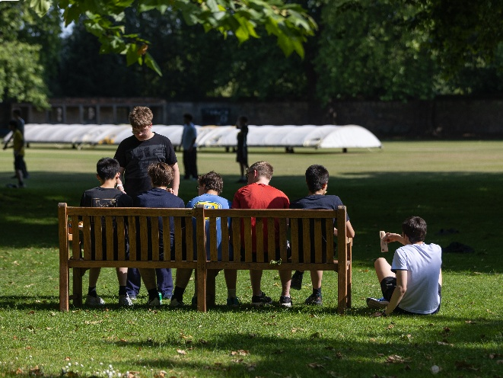

HOW TO APPLY

Only applications completed on the school website will be accepted. Please attach a full CV with your application.

Please note that applications will be dealt with as they arrive. Winchester College reserves the right to appoint before the deadline passes.

Closing date for applications: 11.59pm on 27 May 2026. Shortlisting will take place as applications are received. We expect interviews to take place during the weeks commencing Monday 1 or 8 June 2026.

Those wishing for an informal conversation about this role are invited to speak to Matt Rogers,
Head of Science, mjr@wincoll.ac.uk.

If you have any questions about this vacancy or the recruitment process, please email recruitment@wincoll.ac.uk.

APPLY HERE

Diversity and Inclusion
We embrace diversity and inclusion in the workplace and are committed to promoting a fair and supportive environment for all our employees. We are keen to welcome applications from all applicants that feel that they meet the requirements of the role, regardless of their background and culture.

Data Protection
Winchester College collects and processes relevant personal data as part of its everyday operations and is obliged to process it in accordance with the General Data Protection Regulation and Data Act 2018. The school is the Data Controller of this data under the Act and is registered with the Information Commissioner's Office. Its registration number is Z5751669.

If you have any queries or comments about this policy or how personal data is processed by the school, please contact the Bursar and his team by emailing: dataprotection@wincoll.ac.uk or by writing to: Data Protection, The Bursary, Winchester College, College Street, Winchester, SO23 9NA.


PART FIVE
10

ABOUT WINCHESTER COLLEGE

For nearly 650 years Wykehamists have been taught and nurtured in an atmosphere of intellectual inquiry and academic excellence. In every generation it has helped them leave the college with confidence and curiosity, ready to make their mark upon society. We deliberately give our pupils time, space and freedom to develop their thoughts for themselves.

A large, full boarding school, Winchester is in the process of expanding pupil numbers and transitioning to co-education in the Sixth Form, with the transition expected to be complete by 2029. In 2025, Winchester merged with The Pilgrims’ School, one of the leading academic prep schools for boys with a particularly strong musical tradition founded on its unique status as a double choir school.

Find out more

WHY WINCHESTER COLLEGE? 
EMPLOYMENT





Winchester College
College Street
Winchester, SO23 9NA
United Kingdom

www.winchestercollege.org

Twitter: @WinCol
Instagram: @winchestercollege

